**Samsung AR5500M Wall Mount AC**

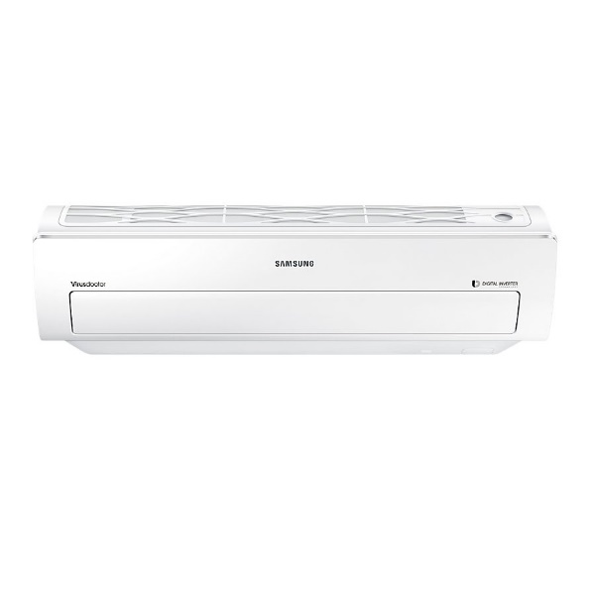

|  |  |  |  |  |  |
| --- | --- | --- | --- | --- | --- |
|  |  | |  |  | |
| **Ton:** | | 1.5 |
| **Fixed or inverter:** | | Fixed |
| **Cooling Capacity(BTU):** | | 18.000 |
| **Air Circulation（m³/h）:** | | 750 |
| **Power Input(W)-Cooling:** | | 1200 |
| **Running Current(A)-Cooling:** | | 9.9 |
|  | | **Indoor Dimension(mm) W/D/H:** | 938/187/265 | |  | |
|  | | **Outdoor Dimension(mm) W/D/H:** | 722/548/285 | |  | |
|  | | **Indoor Weight(kg):** | 13.5 | |  | |
|  | | **Outdoor Weight(kg):** | 32 | |  | |
|  | |  |  | |  | |
|  | | **Compressor:** | Samsung | |  | |
|  | | **Refrigerant:** | R21 | |  | |
|  | | **Refrigerant pipe:** | 75% pure copper | |  | |
|  | |  |  | |  | |
|  | |  |  | |  | |